**PRACTICAL 04**

**Install Samba to share folders or files between Windows and Linux**

STEPS TO SETUP FTP SERVER:

Install the vsftpd package:

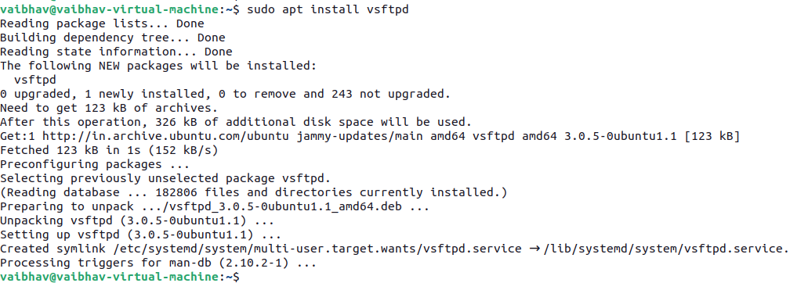

Backup the default configuration file:



Edit the configuration file using a text editor like nano:



To allow local users to access the server, ensure this line is uncommented:

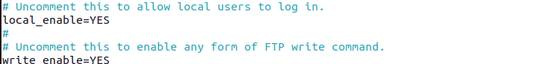

Allow file uploads:



To enable passive mode (useful for firewalls), add these lines at the end of the file:

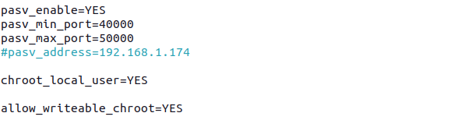

If you have a firewall enabled, allow FTP traffic by running the following commands:

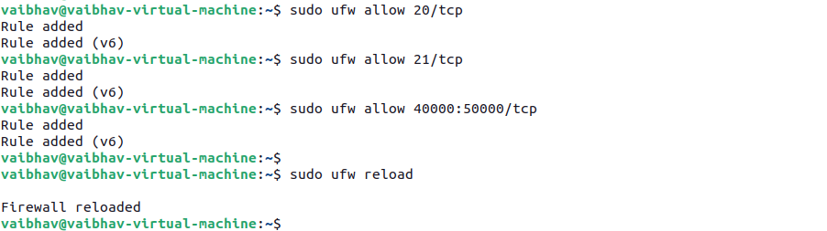

Add a new FTP user:



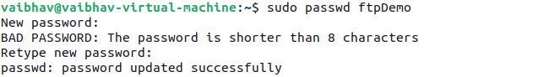

Create a home directory for the FTP user (if needed)



Restart the vsftpd service to apply the changes:



Once the user account has been created and the FTP server is configured to allow local user logins, you can connect to the FTP server as this user.

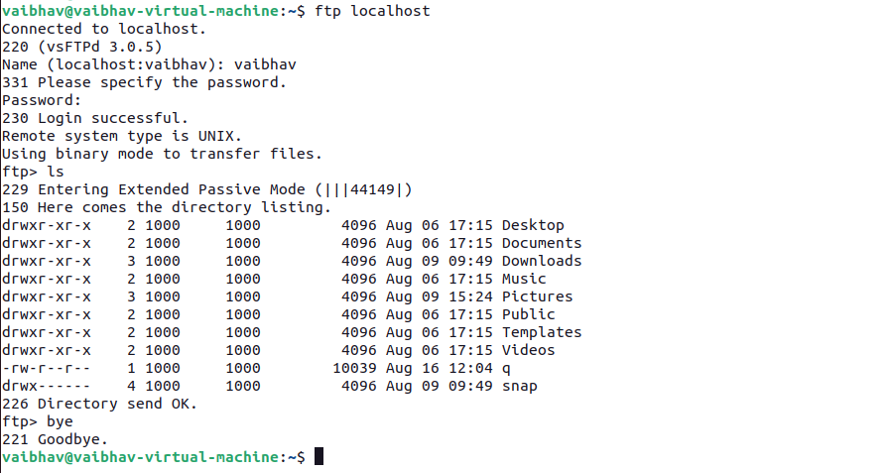

STEPS TO SETUP SAMBA SERVER

First, you need to install the Samba package.

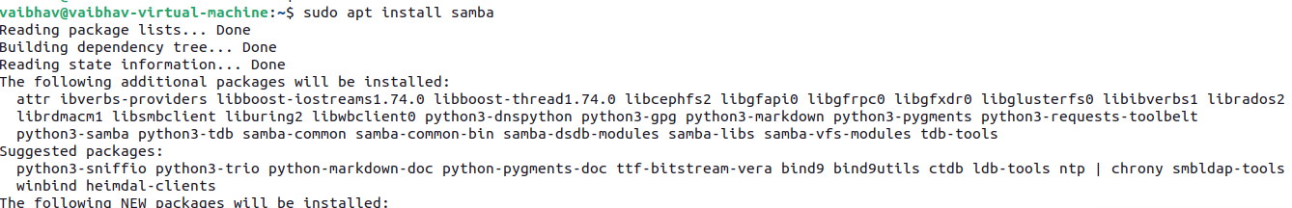

Start the Samba service:



Check if the Samba service is running:

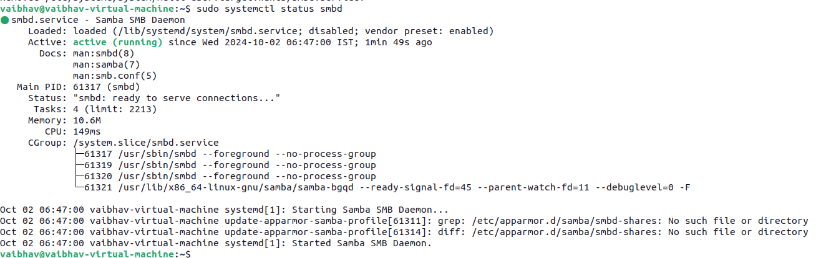

Create a directory that will be shared over the network. In this example, we will create a directory named shared in /srv:



Set the appropriate permissions so that this directory can be accessed. For a public share (accessible to everyone):



Edit the Samba configuration file (/etc/samba/smb.conf) to define the shared folder and its properties.



Add the following lines at the bottom of the file to configure the shared directory:

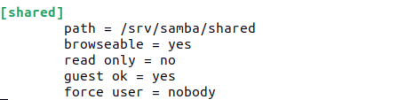

• path: The location of the shared directory.

• browseable: Makes the share visible when browsing.

• read only: Set to no so that users can write to the share.

• guest ok: Allows guest access (no password needed).

• force user: Forces all file access to use a specific user (in this case, nobody).

To apply the changes, restart the Samba services:



If your system has a firewall enabled (e.g., ufw), you'll need to allow Samba traffic:



CLIENT:

Enter the following in the address bar, You should see the shared folder and be able to access it.

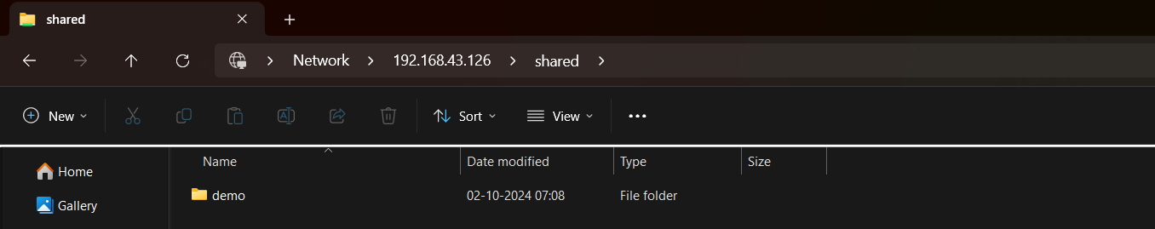



**Enable User Authentication**

Create a samba user with password

sudo adduser sambauser

sudo smbpasswd -a sambauser

[shared]

* guest ok = no
* valid users = sambauser

Now, when accessing the share, you will be prompted for a username and password, and only sambauser can access the share.